IT2654 Systems Administration & Security

Tutorial 2

Discuss within your groups and prepare the answers to be presented in class.

- What is a user profile in Windows Server environment? How many types of user profiles are there? Briefly explain them.
A user profile consists of a registry hive and a group of folders and files that contains the user settings and configuration.

3 types – local, roaming, mandatory.

Local: user’s profile is stored on one particular computer (the computer that the account was saved on). Stored on local PC.

Roaming: user’s profile is stored in the server. This means that any computer connected to the domain can be used to log onto that account. If the user makes any changes to wallpaper, the changes will be saved to the server.

Mandatory: Same as roaming except when user signs out, changes are not saved. Essentially, profile is fixed.

- When a user logs into a domain, where is the user’s profile stored in the following situation?
- Default profile setting (aka local)
Stored in local PC
- Roaming profile
Stored in server
- Mandatory profile
Stored in server

- Describe some good security practises when creating user accounts in a Windows Server environment?
Disable guest account – to prevent hacking
Use a strong password – e.g.: min 10 characters, alphanumeric, special characters
Limit the number of users who can log on locally
Change password on first login
Force periodic password change
Disable accounts that are not used yet
Lock account after x failed login attempts
- What is a Group object in a Windows Domain? Describe a Group key characteristics.
It is a container that is used to organise user’s information in order to simplify administration. You only need to apply the setting once and it will be applied to every account in that Group object.

Categorised by type (security – can assign SID and rights, distribution – email list, no SID) and scope (domain local, global, universal).

- Explain the A G DL P group strategy and give an example on how it can be implemented in a Windows domain (eg. Color printer).
A G DL P is a recommended strategy for using groups in a single domain. As per the A G DL P strategy, you put user accounts (A) into global groups (G), put the global groups into domain local groups (DL), and then grant permissions (P) to the domain local group.

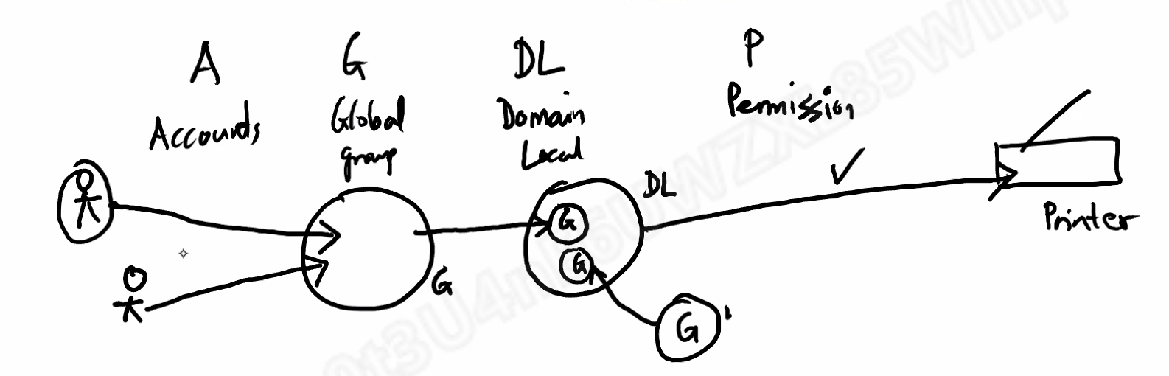

- What are the differences between a Group object and a Organization Unit (OU) object?

- You can link group policies (only for domain, OU and sites) to OUs, but not groups
- You can give file/folder/share permissions to groups, but not OUs
- Groups have a SID, OUs do not
- For OUs, you can put an OU inside the other OU
- You can put a group into an OU, but not an OU into a group
